Head-Impact Data Recording System for Football Injuries

Esam Alzahrani
Abdelkebir Yassine Elmzoudi
Michael Val

ECE 511 Microprocessors
Fall Semester 2011
George Mason University
Instructor: Dr Jens-Peter Kaps

–Abstract –

The purpose of this project report is to summarize for the reader the scope in which we designed a Head-Impact Data Recording System for Football Injuries. This system transmits impact data wirelessly for remote logging. This report goes beyond simply explaining how our device works and its significance in society today; this document also discloses the design challenges we faced, the design tradeoffs we were forced to choose between, and how we as a team were challenged to overcome cross functional issues in order to design a system that would meet a complete set of operational requirements that would be imposed upon our system when it is implemented in the field.

–Abstract –
Table of Contents
1. Introduction 3
2. Design Objective 3
3. Architecture 3
4. Design Execution 4
4.1 Wireless Communication 4
4.2 Impact Detection 4
4.3 Operator Interface 4
4.4 PCB Design 4
5. Results and Issues 5
5.1 Wireless Communication 5
5.2 Impact Detection 5
5.3 Prototype PCB 5
5.4 Further Development 5
5.5 Conclusions 5
6. References 6

Introduction
Head injuries, including concussions, particularly in the game of American football, have become a subject of deep concern. A 2000 study surveyed 1,090 former N.F.L. players and found more than 60 percent had suffered at least one concussion in their careers and 26 percent had had three or more.
N.F.L. players who recalled sustaining three or more concussions on the football field, 20.2 percent said they had been found to have depression (NY Times).

The purpose of this project is to develop a system that will help medical professionals treat football injuries more efficiently.

Design Objective
A system will be designed that will detect impacts to a football player's helmet. The system will inform the medical professionals on the sideline of any high-g impacts. The medical professionals will be able to setup the system for different types of impacts. Using the system data, medical professionals will be able to evaluate, treat, and hopefully prevent further trauma to the football player.

Architecture
The system consists of 2 parts – a part to be installed in the player's helmet (SENSOR), and a part that will connect to a side-line laptop (DAQ). The SENSOR will detect high-g impacts and wirelessly transmit them to the 'DAQ'. The DAQ will control operations of the SENSOR, and transmit data to a laptop for storage.

The SENSOR consists of an MSP430G2231 microcontroller, BMA180 accelerometer, and an XBee wireless transceiver. The DAQ consists of an XBee wireless transceiver and adapter board to which a laptop connects via RS232.

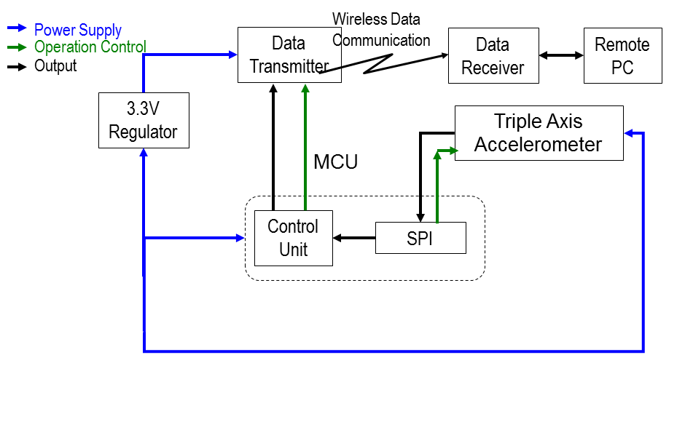
Figure 1: Block level diagram of the proposed system

Design Execution

Wireless Communication
For prototype development, a Pro version of the XBee was used. For the 2nd SENSOR prototype, a non-Pro version is used because of lower power consumption.

The XBee on the SENSOR part of the system is hooked up to the TX/RX UART pins of the MSP430 (P1.1 and P1.2) operating at 9600 baud. Using Timer_A CCR0 hardware output modes and SCCI data latch. The desired sleep mode of this XBee is Cyclic Sleep. The Xbee wakes up on a timer, and polls the DAQ's XBee for user input.

On the SENSOR part of the system, the impact (BMA180) data will be sent to the XBee PRO 802.15.4 radio where it will be packetized and transmitted wirelessly to the remote PC. The sensory data will be viewable in a communications port terminal emulator window and can be saved in text format to the local hard drive of the PC.

The XBee on the DAQ (laptop) part of the system is hooked up to a COM port through an RS232 or USB connection. The desired setup of this XBee unit is as a 'coordinator'. Indirect transmission allows for system operator COM commands to be buffered and polled periodically by the client SENSOR XBee.

Impact Detection
The BMA180 accelerometer is a part of the SENSOR part of the system. The BMA180 is hooked up to the MSP430 SPI pins. The MSP430 is setup as a Master using the USI control registers. The BMA180 has an 8-bit register architecture for control, status, and data. The MSP430 uses the USISRL to read and write address and data. The USICNT is used to control the number of bits sent/received.

The BMA180 is primarily setup to send an interrupt to the MSP430 once a high-g impact is detected. The high_int registers are used to setup threshold, hysteresis, duration, etc.

The BMA180 interrupt parameters need to be calibrated by the system operator for use out in the field.

Operator Interface
A the beginning and ends of the football game, the operator of the system will manually switch off the SENSOR in each of the helmets in use. During the game, the operator of the system will use the DAQ (laptop) RS232 COM interface to get status, impact data, as well as set up different system parameters.

A power-up greeting presents status message: system specs, designer/manufacturer info, as well as system version. A system status (current system settings) will be presented to the operator, as well as a command menu that allows for these parameters to be changed such as impact interrupt thresholds, impact readings, and system status.

PCB Design
A SENSOR PCB was designed and fabricated. The focus was on low-power consumption and small footprint. The PCB ended up at 2 x 1.5inches. Extra optional headers were added for debugging purposes. A CR2032 (3V, 250mAh) battery is the desired battery to be used. Schematic and layout can be found in Appendix D and E.

Results and Issues

Wireless Communication
Wireless communication was established, and successful data transfers were made. There were some issues along the way though such as UART sharing on the USI with SPI operations as well as displaying ASCII data properly. To overcome the sharing issue we had to change our specifications by not using the UART while we are using SPI module. In other word, when we are acquiring accelerometer data, no Xbee transmission is issued. Getting ASCII data displayed on the HyperTerminal took us a lot of time to understand this behavior: first we thought the issue was related to the HyperTerminal itself so we had to use different serial data applications. After that, we understood that we had to write a piece of software to convert data to string.

Impact Detection
Successful operation of the BMA180 accelerometer was established. The BMA180 was tested at a +2G range settings, and a 1G reading was read, indicating correct operation of the device.

There were some issues here as well. Bringing up the SPI interface between the MSP430 and BMA180 took a long time. First, we were using only 8-bit data on SDI line to communicate with the BMA180 as it is described in the BMA180 data sheet but we were getting back incorrect data. By changing the request data from 8-bit to 16-bit, we got back what we are expecting as response on the SDO line.

Prototype PCB
The PCB was successfully manufactured and assembled. A simple program was loaded onto the MSP430 to test UART functionality with the XBee. The UART functionality was tested with an RS232 pigtail attached header pins on the PCB, which then attached to a PC. After that, basic UART operations with the XBee were tested – a simple character enter and return in windows hyperterminal showed correct functionality of the MSP430 and XBee subsystem of the PCB. Unfortunately because of time constraints, the MSP430 and BMA180 subsystem still needs to be tested.

Some issues were found during debugging of the PCB. SDI and SDO SPI signals were crossed between the BMA180 and MSP430. Traces were cut and jumpers were installed. A few parts (headers) were late in delivery, resulting in delayed prototyping. Programming of the MSP430 still needs to be done with a Launchpad because spy-by-wire interface was brought out, instead of the jtag interface. The BMA180 is extremely difficult to solder on by hand. Should not be a problem for a professional assembly house.

Further Development
The operator interface needs to be further developed to allow system parameters to be changed wirelessly. The XBee coordinator needs to be set up to allow cyclic sleep on hosts SENSOR units.
Connections to multiple SENSOR units need to be tested. The SENSOR PCB needs to be debugged further and tested with all features.

Conclusions
This project was fun! We hit a lot of roadblocks that we were able to overcome, and some that with enough time we would be able to overcome. Even though we do not have a polished product on our hands, it is a good initial prototype.

Much was learned during this project, from conceptual understanding of SPI operations, to detailed integration of USI functionality, to integration of a system on a PCB. A major part of the learning was working in a team as well – sharing responsibilities and helping each other progress.

Also we were forced to think “outside the box” and consider alternative ways of implementation in order to reduce size, cost while meeting design objectives. We were also forced to research and gain an understanding of many concepts new to us.

References
- MSP430 coding references obtained from here
- MSP430 resources including Launchpad schematic and layout from here
- BMA180 datasheet and coding examples from here
- NY Times football injuries article found here

Appendix A: Team Members and Responsibilities
This project has taught us some invaluable lessons about teamwork. Each of our team members possesses different yet unique and valuable skills and personalities. Each member comes from unique cultures and countries around the world. We have learned to come together as a team; to cooperate; to communicate; to share responsibility; to consensually form and reach objectives and goals.

Esam Alzahrani was responsible for investigating and coming up with a theory of operation for the BMA180 accelerometer, as well as implementing preliminary configuration for interrupts of the BMA180.

Yassine Elmzoudi was responsible for implementing and testing the SPI interface between the MSP430 and BMA180, and the UART interface between MSP430 and XBee as well as integration with all the components.

Michael Val was responsible for designing and testing a prototype PCB, providing assistance with debugging the SPI, as well as helping come up with the user interface for communicating over UART.

Appendix B: Software Flowchart

Appendix C: Complete Parts List
Exported from ece511_board.sch at 11/28/2011 9:22:15 AM

EAGLE Version 5.11.0 Copyright (c) 1988-2010 CadSoft

Part Value Device Package Library Sheet

C1 100nF C_SMD0603 0603 ssmd 1
C2 10uF/10V C_0805 0805 ssmd 1
C3 100nF C_SMD0603 0603 ssmd 1
C4 10uF/10V C_0805 0805 ssmd 1
C6 1nF C_SMD0603 0603 ssmd 1
C7 100nF C_SMD0603 0603 ssmd 1
C8 10uF/10V C_0805 0805 ssmd 1
G1 CR2032H CR2032H CR2032H battery 1
JP1 PINHD-1X2 1X02 pinhead 1
L1 10uH INDUCTOR0603 0603 SparkFun 1
L2 10uH INDUCTOR0603 0603 SparkFun 1
L3 10uH INDUCTOR0603 0603 SparkFun 1
LED1 green LED_0603D0603 DIODE0603 SMD 1
LED2 red LED_0603D0603 DIODE0603 SMD 1
LED3 Power LED_0603D0603 DIODE0603 SMD 1
P1 M05PTH 1X05 SparkFun 1
R1 470R R_SMDR0603 0603 ssmd 1
R2 470R R_SMDR0603 0603 ssmd 1
R3 270R R_SMDR0603 0603 ssmd 1
R5 47K R_SMDR0603 0603 ssmd 1
SL1 M11 11P con-amp-quick 1
SL2 M11 11P con-amp-quick 1
SL3 M05 05P con-amp-quick 1
U1 MSP430 DIL20S SOCKET-20 ic-package 1
U2 BMA180 BMA180 LGA12 SparkFun 1
U3 XBEE-1B3 XBEE-1B3 XBEE-SMD SparkFun 1
X1 QUARZ5 QUARZ5 QUARZ5 sMSP430 1

Appendix D: PCB Schematic
All source board files can be found in the project package attached with this report under the PCB folder.
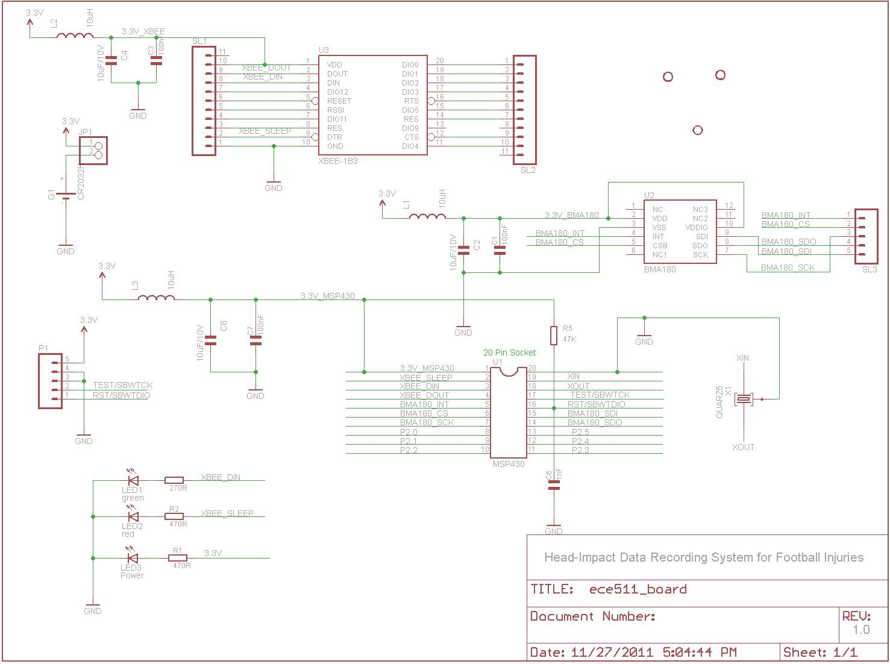

Appendix E: PCB Layout
All source board files can be found in the project package attached with this report under the PCB folder.
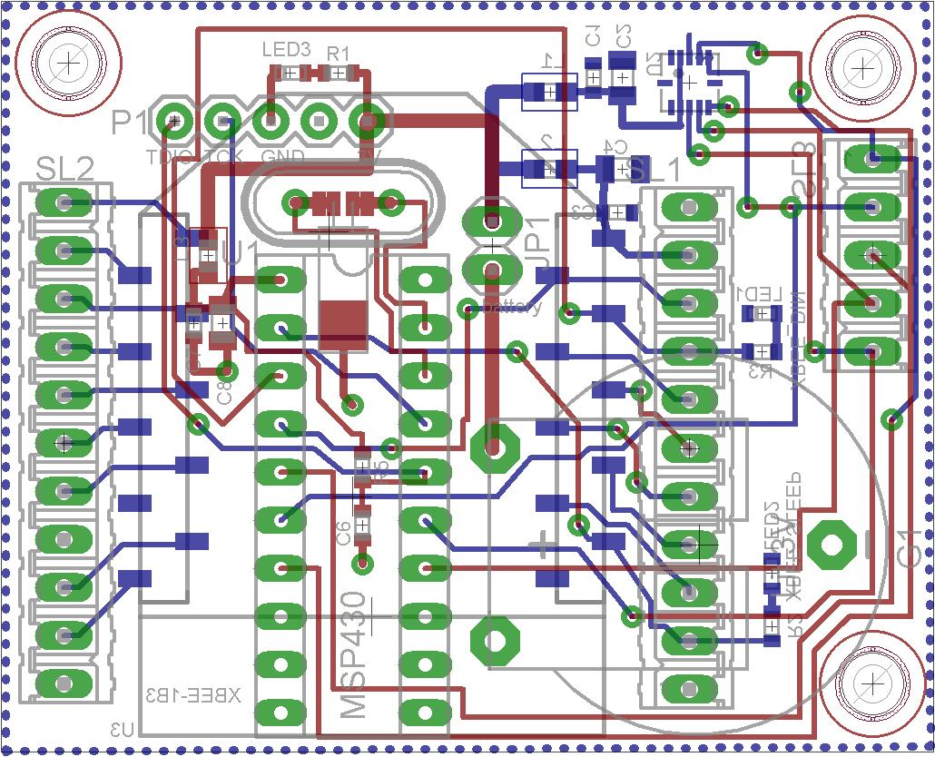

Appendix F: PCB Fab
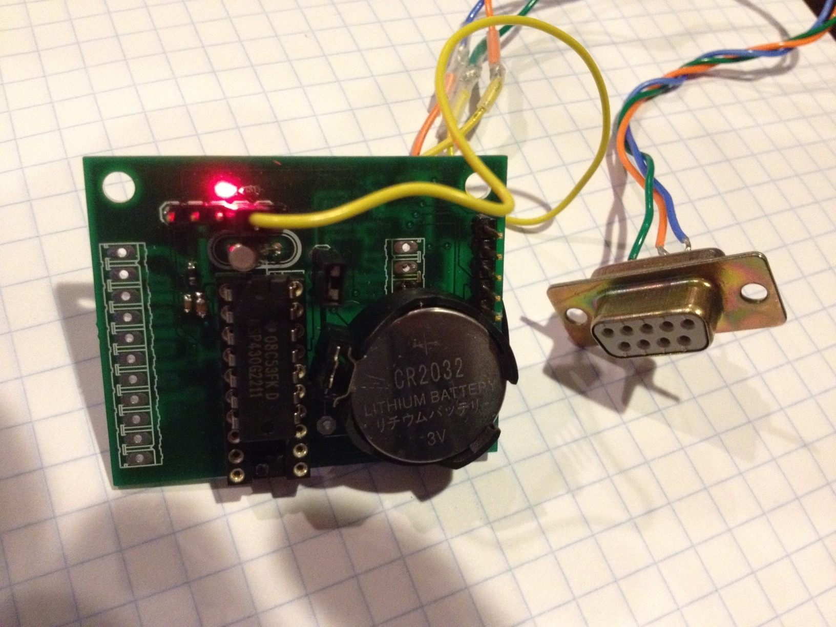

Appendix G: Development Prototype
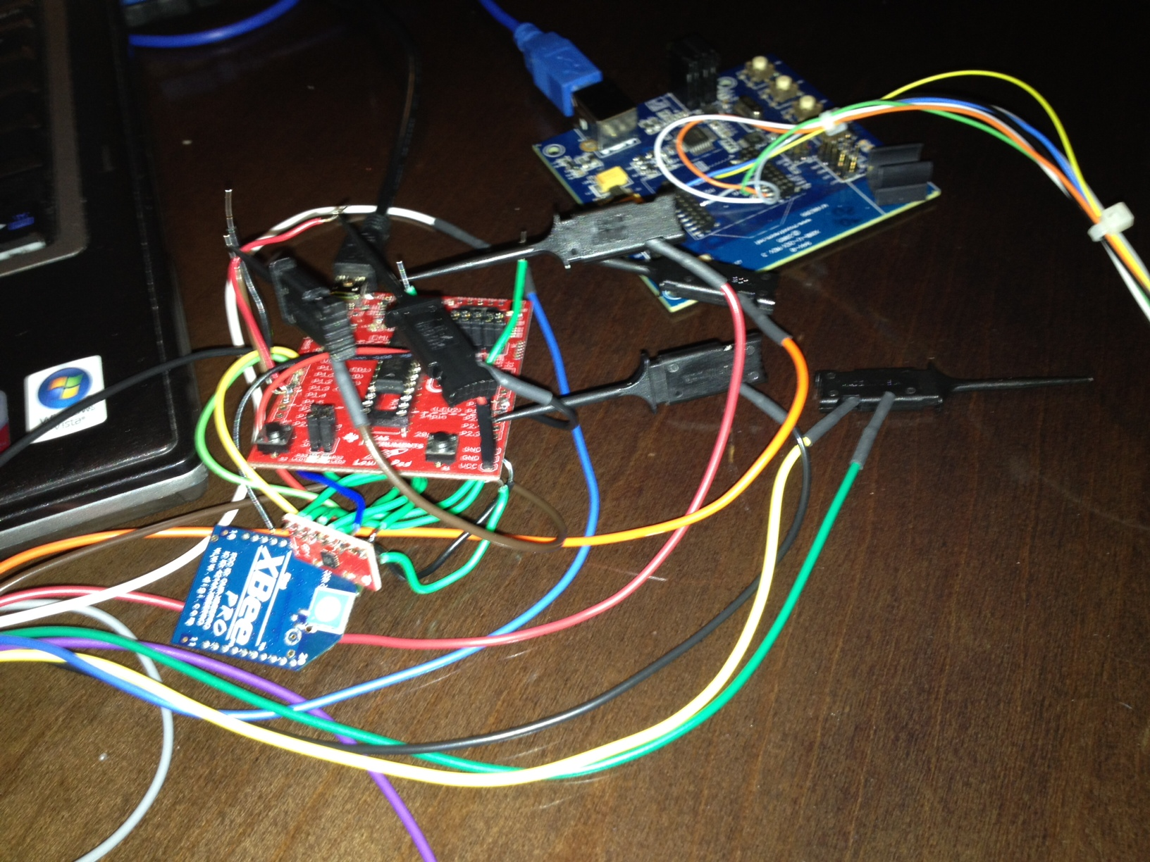

Appendix H: SPI Screen Captures
